

VistA Blood Establishment Computer Software (VBECS) Version 2.0.0.6

Patch Installation Guide

January 2015

Department of Veterans Affairs

Product Development

This page intentionally left blank.

# Revision History

| **Date** | **Revision** | **Description** | **Author** |
| --- | --- | --- | --- |
| 1-23-15 | 1.0 | Initial version. | BBM team |

This page intentionally left blank.

Table of Contents

Revision History ii

Table of Contents iv

Introduction 1

Related Manuals and Reference Materials 1

Orientation 3

How This Installation Guide Is Organized 3

Appendices 3

Warnings 3

Screen Shots 3

VBECS Patch Support Team 4

Problems? 4

VBECS Patch Workflow 7

1 VBECS Project Manager (PM): Initiates a Patch Request 7

2 EO VBE Build Manager: Begins Patch Preparation 7

3 EO VBE System Administrator (SA): Readies the App Server 8

4 EO VBE Database Administrator (DBA): Installs the Patch 8

5 EO VBE Build Manager: Reviews the Patch Documentation 9

6 VBECS Project Manager (PM): Notifies the Blood Bank 9

Glossary 11

Appendices 13

Appendix A: Downloading and Verifying the Patch File 13

Appendix B: Installing the VBECS Patch 17

Appendix C: Configuring Internet Explorer for VBECS FTP Use 23

Appendix D: Troubleshooting 25

Appendix E: Installation Logs and Database Backup Files 29

This page intentionally left blank.

Introduction

VBECS is a Blood Bank application that facilitates ongoing compliance with Food and Drug Administration (FDA) standards for medical devices and enhances the VA’s ability to produce high-quality blood products and services to veterans. The system follows blood bank standards, standards of national accrediting agencies, FDA regulations, and VA policies.

 Unauthorized access or misuse of this system and/or its data is a federal crime. Use of all data must be in accordance with VA security and privacy policies.

 The U.S. FDA classifies this software as a medical device. Unauthorized modifications will render this device an adulterated medical device under Section 501 of the Medical Device Amendments to the Federal Food, Drug, and Cosmetic Act. Acquiring and implementing this software through the Freedom of Information Act requires the implementer to assume total responsibility for the software and become a registered manufacturer of a medical device, subject to FDA regulations. Adding to or updating VBECS software without permission is prohibited.

This document describes how the Enterprise Operations (EO) VBE Systems Administrator and VBE Database Administrator patch VBECS. It describes the steps that must be executed and the arguments that must be supplied. It specifies how to read output and the actions that must be performed as a result of the output.

## Related Manuals and Reference Materials

* *VistA Blood Establishment Computer Software (VBECS) 2.0.0 Technical Manual-Security Guide*

This page intentionally left blank.

# Orientation

## How This Installation Guide Is Organized

 Maintain the order of the steps for successful installation.

This guide is organized as follows:

## Appendices

*Appendix A: Downloading and Verifying the Patch File* iscompleted by the EO VBE System Administrator.

*Appendix B: Installing the VBECS Patch* is completed by the EO VBE Database Administrator.

*Appendix C: Configuring Internet Explorer for VBECS FTP Use* provides guidance for setting up Internet Explorer options.

*Appendix D: Troubleshooting* contains examples of troubleshooting messages.

*Appendix E: Installation Logs and Database Backup Files* contains file details.

## Warnings

Outlined text with a caution icon is used throughout the guide to highlight warnings, limitations, and cautions:

 Read and follow these Warnings, Limitations, and Cautions statements.

## Screen Shots

Because VBECS is a medical device, screen shots must be captured at verification points throughout the installation. These screen shots are used to meet regulatory requirements for objective evidence and documentation.

A  (camera) at the beginning of each step that requires a screen capture will identify these points.

To capture a screen shot:

1. When the screen you wish to capture is displayed:

* Press **Alt+Print Screen** to capture only the screen where the cursor is located.
* Press **Print Screen** to capture the entire screen.

1. In the *VBECS 2.0.0.6 Patch Installation Form* (commonly referred to as “*Patch Installation Form*” throughout this document), place the cursor where you want to insert the screen shot.
2. Press **Ctrl + V** to paste.

 Screen shots included in this guide are examples only and may not display actual data.

## VBECS Patch Support Team

## Problems?

Contact the **VBECS Patch Support Team POC** listed in the *Patch Installation Form* for any problems encountered while patching. Send a copy of the installation log file (see *Appendix E: Installation Logs and Database Backup Files*) to the group at [VAOITVBECSImplementationSupport@va.gov](mailto:VAOITVBECSImplementationSupport@va.gov).

Office Hours (Monday – Friday, 8am – 3pm CT).

|  |  |  |  |
| --- | --- | --- | --- |
| **Title** | **Name** | **Work Phone** | **Official Cell Phone** |
| **Project Manager** | **Kevin Kania** | **815.254.0334** | **630.740.3493** |
| **Lead Developer** | **Carrie Van Stedum** | **708.777.1293** | **708.655.9877** |
| **Database Administrator** | **Kwame Adu-Poku** | **708.279.4830** | **260.804.9410** |
| **Systems Administration Support** | **Carl Jensen** | **970.744.3105** | **970.744.3105** |
| **Developer** | **Greg Lohse** | **708.786.5951** | **630.881.0775** |

Diagram 1: Patch Workflow



This page intentionally left blank.

VBECS Patch Workflow

Refer to Diagram 1: Patch Workflow for a visual display of the activities.

### VBECS Project Manager (PM): Initiates a Patch Request

**The VBECS PM or designee:**

 If requesting a patch for the Production environment: VBECS 2.0.0.6 must be installed and validated in the Test environment before the Production environment can be patched to VBECS 2.0.0.6.

1. Verifies that VBECS 2.0.0.5 is installed and validated in the target environment.
2. Confirms with the blood bank that Patch VBEC*1*54 has been applied to the appropriate VistA account.
3. Prepares a *Patch Installation Form* for the EO Build Manager by following the directions at the start of the form.
4. Sends an email to the **VA IT SDE EO EAS VBE Build Management** group to create a Service Request (SR) for the patch, attaching the *Patch Installation Form* from the previous step.

### EO VBE Build Manager: Begins Patch Preparation

**The EO VBE Build Manager:**

 For fields enclosed in brackets (e.g., <***VBECS App Server***>), refer to the *Patch Installation Form* for their intended values.

1. Receives the email with the attached *Patch Installation Form* and creates an SR*.*
2. Creates a Change Order (CO) to have the patch installed on the <***VBECS App Server***> at the time specified in the *<****Patch Installation Date****>*. Records their name and the CO number on the *Patch Installation Form*.
3. Creates a request for EO VMware System Administration AITC to take a snapshot of <***VBECS App Server***> (snapshots require a 24-hour advance notice).
4. After receiving confirmation that the snapshot has completed, checks the box in the *Patch Installation Form*.
5. Saves and attaches the working *Patch Installation Form* to the CO.
6. Notifies the VBECS Patch Support Team to verify the <***Environment***> specified in the *Patch Installation Form* is ready to proceed.

 The patch will fail if Step 6 is skipped and the patch environment is not verified by the VBECS Patch Support Team.

1. Waits for a response from the VBECS Patch Support Team that the patch process can proceed.
2. Assigns the CO to an EO VBE Systems Administrator and EO VBE Database Administrator instructing them to continue with Section 3 of this guide.

### EO VBE System Administrator (SA): Readies the App Server

**The EO VBE SA:**

 For fields enclosed in brackets (e.g., <***VBECS App Server***>), refer to the *Patch Installation Form* for their intended values.

1. Retrieves the *Patch Installation Form* from the CO and records their name on it.
2. Adds the assigned EO VBE DBA or DBA group to the local Administrators group of the <***VBECS App Server***> to be patched*.*
3. Places Systems Central Operations Manager (SCOM) into Maintenance Mode for <***VBECS App Server***>.
4. Completes Appendix A: Downloading and Verifying the Patch File.
5. Saves and attaches the *Patch Installation Form* to the CO.
6. Notifies the EO VBE DBA to complete Section 4 of this guide.

### EO VBE Database Administrator (DBA): Installs the Patch

**The EO VBE DBA:**

 For fields enclosed in brackets (e.g., <***Environment***>), refer to the *Patch Installation Form* for their intended values.

1. Retrieves the *Patch Installation Form* from the CO and records their name on it.
2. Determines which SQL AlwaysOn server is Primary; if Server A is not Primary, performs a manual failover to make Server A the Primary replica for all Availability Groups [refer to the *Applying Updates to VBECS SQL Server System* section of *VBECS 2.0.0 Technical Manual-Security Guide*].
3. Completes *Appendix B: Installing the VBECS Patch* for the <***Environment***> specified in the *Patch Installation Form*.
4. Saves and attaches the completed *Patch Installation Form* to the CO.
5. Notifies the EO VBE Build Manager to complete Section 5 of this guide.

### EO VBE Build Manager: Reviews the Patch Documentation

**The EO VBE Build Manager:**

 For fields enclosed in brackets (e.g., <***VBECS App Server***>), refer to the *Patch Installation Form* for their intended values.

1. Notifies the EO VBE SA to do the following:

* Remove SCOM from Maintenance Mode for <***VBECS App Server***>.
* Remove the DBA’s local administrative permissions from <***VBECS App Server***>.

1. Reviews the completed *Patch Installation Form* and verifies that all EO actions are recorded. If any problems (failures or incomplete documentation) or deviations are encountered, notify the VBECS Patch Support Team immediately for further instruction.
2. Completes the Review section of the *Patch Installation Form*.
3. Prints, scans and emails the completed *Patch Installation Form* to the VBECS Patch Support Team ([VAOITVBECSImplementationSupport@va.gov](mailto:VAOITVBECSImplementationSupport@va.gov)).

### VBECS Project Manager (PM): Notifies the Blood Bank

**The VBECS Project Manager or designee:**

1. Notifies the blood bank their ***<VBECS App Server>*** has been successfully patched to 2.0.0.6 and to verify the system by placing, accepting and resulting one test order.
2. Files a copy of the completed *Patch Installation Form* on the appropriate SharePoint folder and in the Project Document Storage System.
3. Changes the final workflow task of the CO to completed. This completes and closes the CO.

This page intentionally left blank.

Glossary

| **Acronym, Term** | **Definition** |
| --- | --- |
| **AITC** | Austin Information Technology Center. |
| **CA** | CA Service Desk Manager. |
| **CO** | Change Order. |
| **DBA** | Database Administrator. |
| **EO** | Enterprise Operations. |
| **FDA** | Food and Drug Administration. |
| **FTP** | File Transfer Protocol. |
| **NMEA** | Non-eMail Enabled Account, meaning that these accounts are for admin use only and do not have an email account associated with them. |
| **Remote Desktop Connection (formerly Terminal Services)** | The connectivity tool used to access VBECS on the server. |
| **SCOM** | Systems Center Operations Manager. |
| **SR** | Service Request. |
| **VA** | Department of Veterans Affairs. |
| **VBE** | Enterprise Operations project name for VBECS. |
| **VBECS** | VistA Blood Establishment Computer Software. |
| **VistA** | Veterans Health Information Systems and Technology Architecture. VistA software, developed by the VA, is used to support clinical and administrative functions at VA Medical Centers nationwide. VistA is composed of packages that undergo a verification process to ensure conformity with name spacing and other VistA standards and conventions. |

This page intentionally left blank.

# Appendices

## Appendix A: Downloading and Verifying the Patch File

Prerequisites for VBECS FTP Download:

* You must be an administrator on <***VBECS App Server***>.
* You must be a member of **VA IT SDE EO EIS Wintel Admins All (AITC)** with an email-enabled account.

Once the above prerequisites are met:

1. On a remote desktop connection to <***VBECS App Server***>, open Windows Explorer.
2. In the **Address** field, type **ftp://10.3.9.181:20001** (Figure 1) and press **Enter**. If you encounter problems accessing the FTP site, contact the VBECS Patch Support Team.

Figure 1: Connecting to VBECS FTP Site

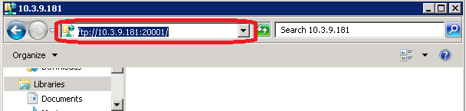

1. On the Log On As dialog, enter your **domain and Windows user account** and **password** and click the **Log On** button (Figure 2).

* Note: NMEA (Non-eMail Enabled Account) accounts cannot be authenticated by the FTP server, so you must access the FTP site using an email enabled Windows user account.*

Figure 2: Example of FTP Log In

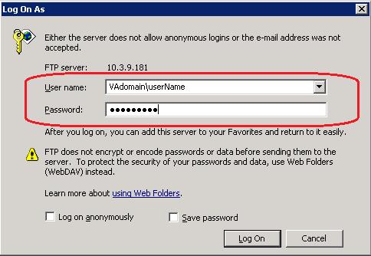

 If access problems are encountered, contact the VBECS Patch Support Team. **Do not proceed until the issue is resolved.**

1. Copy the **VBECS_Patch_2.0.0.6_011215.zip** file to the **C:\temp** directory.

 If you encounter the '**Your current settings do not allow you to download files from this location**' error, see Appendix C: Configuring Internet Explorer for VBECS FTP Use for instructions on how to resolve this problem.

1. Right-click on **VBECS_Patch_2.0.0.6_011215.zip** and select **Extract All**.
2. After the Extraction Wizard opens, uncheck **Show extracted files when complete** and click **Extract** (Figure 3).

Figure 3: Extracting the VBECS Patch File

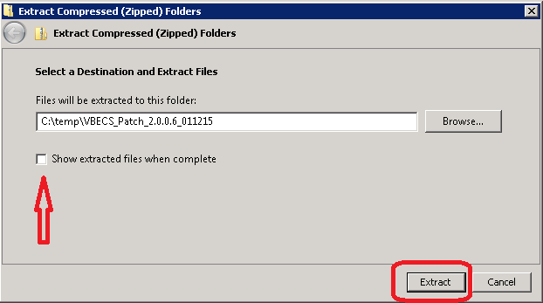

1. In Windows Explorer, right-click on the newly created **VBECS_Patch_2.0.0.6_011215** folder and select **Properties**.
2. In the folder properties window (Figure 4), verify:
   * **Size** is **45.0 MB (47, 210, 792 bytes)**
   * **Contains 152 Files, 21 Folders**

Figure 4: Example of VBECS Patch Folder Properties

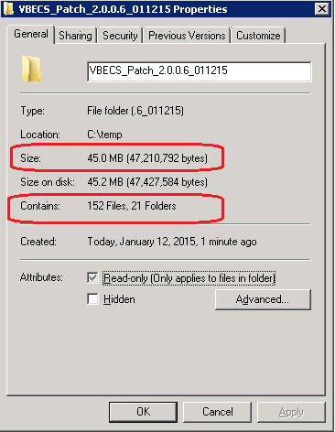

 If the number of files and number of bytes do not match, stop and contact the VBECS Patch Support Team. **Do not proceed until the issue is resolved.**

1. After verifying that the contents match Figure 4, capture a screen shot of the VBECS_Patch_2.0.0.6_011215 Properties window and insert it into the *Patch Installation Form.*
2. Click **OK** to dismiss the Properties window.
3. Select the **VBECS_Patch_2.0.0.6_011215.zip** file, and while holding down the **Shift** key, press the **Delete** key. Click **Yes** to confirm file deletion.
4. Return to Section 3 Step 5 and continue.

This page intentionally left blank.

## Appendix B: Installing the VBECS Patch

Plan to execute the VBECS patch when no active users are on the servers. The patch will identify any user connections found at the time the patch is started.

Do not run any additional applications on the server while the patch is executing.

1. On a remote desktop connection to <***VBECS App Server***>, open Windows Explorer and navigate to **C:\temp\VBECS_Patch_2.0.0.6_011215**.
2. Double-click the **prepare.bat** file. Shortcuts for **prod** and **test** are created (Figure 5).

 For Environments where Production databases have not been migrated for the <***VBECS App Server***>, only test shortcuts will be created.

Figure 5: Example of Patch Shortcuts

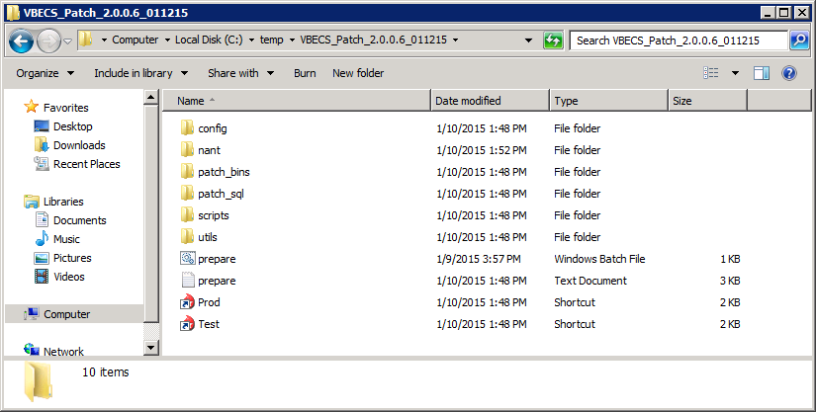

1. Double-click the shortcut for the <***Environment***> specified in the *Patch Installation Form*.
2. Verify all information displayed in the VBECS Patch window against the *Patch Request Information* table of the *Patch Installation Form*. Enter any contact information displayed as ([**NotFound**]) before continuing (Figure 6).

* **Contact Name** – enter your full name.
* **Contact E-mail** – enter your email address.
* **Contact Phone** – enter your telephone number.

 If any of the information presented does not match the Patch Installation Form, stop and contact the VBECS Patch Support Team. **Do not proceed until the issue is resolved.**

Figure 6: Example of VBECS Patch Window

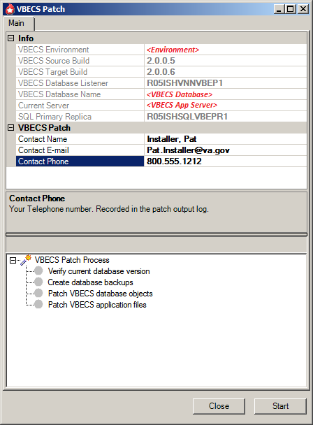

1. Capture a screen shot of the VBECS Patch window and insert it in the *Patch Installation Form.*
2. Click **Start**.

 If the patch detects abnormalities with your system environment, you will be presented with additional screen prompts not described in this section. Consult Appendix D: Troubleshooting for further information on how to proceed.

1. A prompt to verify that all required VistA patches are installed appears (Figure 7).

Figure 7: Example of VistA Patch Required Message

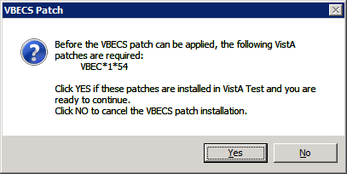

1. Click **Yes** only if the **VistA Patches** box on the *Patch Installation Form* is checked; otherwise, click **No** and consult the VBECS Patch Support Team.
2. A prompt to verify that a VM snapshot of <***VBECS App Server***> has been taken is displayed (Figure 8). Consult the EO Build Manager section of the *Patch Installation Form* to verify a snapshot has been completed.

* Click **No** if the checkbox is not checked, and contact the EO Build Manager.
* Click **Yes** only if the snapshot box is checked.

Figure 8: Example of VBECS Patch: VM Snapshot Required

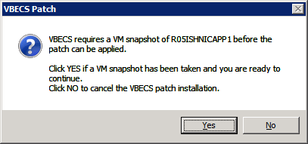

1. If any existing user connections are detected, you will receive the following prompt (Figure 9). Click **Yes** to continue after verifying with the EO Build Manager that the users have been notified of the patching process.

Figure 9: Example of VBECS Patch: Review Connected Users

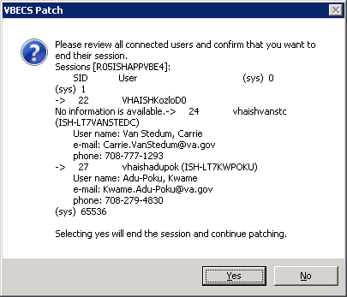

1. Refer to Figure 10 for the following:

* A green “patch is working” animation () in the bottom left of the VBECS Patch window will be in motion while the patching is in progress.
* A blue progress bar () will increment based on the overall patch progress.
* **VBECS Patch Process** displays checkpoints in the patching routine. A green check mark  indicates that the process step completed successfully; a  indicates a failure.

*If the patch fails to successfully complete within 10 minutes, contact the VBECS Patch Support Team immediately.* ***Do not stop the patch process and do not release VBECS for use until the issue is resolved.***

Figure 10: Example of a Running VBECS Patch

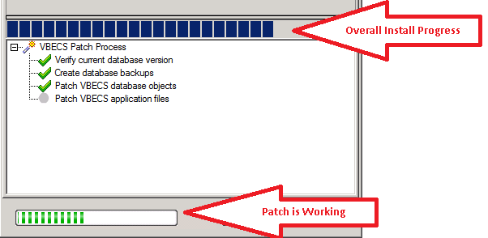

1. If all checkpoints complete, “**The** **VBECS Patch process completed successfully**” message displays*.*

 *If a Patch Failure message is displayed, refer to Appendix D: Troubleshooting. If no solution to the failure message is found, contact the* VBECS Patch Support Team *immediately.* ***Do not proceed or release VBECS for use until the issue is resolved.***

 *By design, there may be non-fatal errors and warnings within the log file output. Ignore warnings and non-fatal errors upon successful completion of the VBECS Patch process.*

1. If the patch completed successfully, enter today’s date on the *Patch Installation Form*.
2. Click **Close** to close the VBECS Patch success message.
3. Click **Close** on the VBECS Patch window to exit the application.
4. Using windows explorer, navigate to **C:\temp**.
5. Select the **VBECS_Patch_2.0.0.6_011215** folder, and while holding down the **Shift** key, press the **Delete** key. Click **Yes** to confirm folder deletion.
6. Check the box in the *Patch Installation Form*.
7. Log off the <***VBEC App Server***> remote desktop connection.
8. Return to Section 4 Step 4 and continue.

This page intentionally left blank.

## Appendix C: Configuring Internet Explorer for VBECS FTP Use

On the VBECS Application Server:

1. Click **Start**: type **internet options** and select the top menu item that displays (Figure 11).

Figure 11: Example of Internet Explorer Window

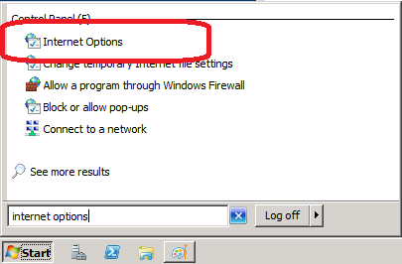

1. Select the **Security** tab: select **Trusted sites** and click **Sites** (Figure 12).

Figure 12: Example of Internet Explorer Internet Options Security Tab

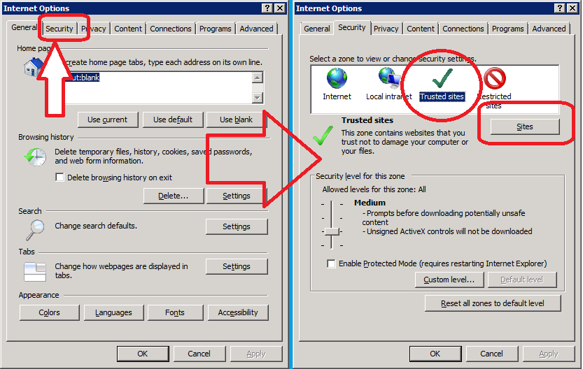

1. Make sure **Require server verification…** is unchecked. Enter **ftp://10.3.9.181** and click the **Add** button (Figure 13).

Figure 13: Adding VBECS FTP to the Trusted Sites

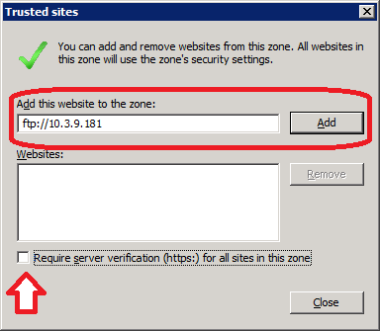

1. Click **Close** and click **Custom level**.
2. Scroll down and verify that **Downloads, File download** is Enable. Click **OK** (Figure 14).

Figure 14: Security Settings-Internet Zone

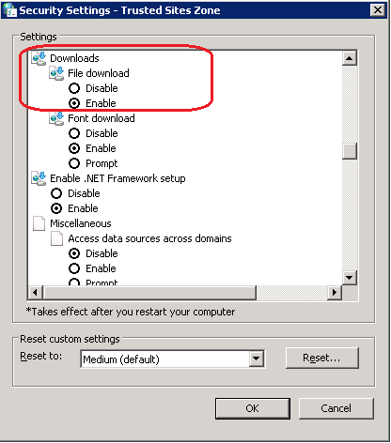

1. Click **OK** to close the Internet Properties windows.

## Appendix D: Troubleshooting

| **Error Message** | **Example Screen Shot and Solution** |
| --- | --- |
| A Security Alert is received when attempting to download from the FTP site. |  |
| **Solution:**  Follow the instructions detailed in Appendix C: Configuring Internet Explorer for VBECS FTP Use and retry the FTP connection. |
| The Start button of the VBECS patch is disabled. |  |
| **Solution:**  This is normal. The Start button is disabled while the patch is running and after the patch completes. |
| Users Remote Desktop Connection was terminated by the patch. |  |
| **Solution:**  This is normal. The patch terminates all opened remote desktop connections to the application server. No users are allowed on the system during patching. |
| The patch was denied access to an application file. |  |
| **Solution:**  Close the identified file being accessed by a user and restart the patch.  Ensure that no users are connected to the application server. |
| The patch detected active database connection(s) |  |
| **Solution:**  Close the identified connection/application and restart the patch.  Use the information contained in the message to identify the user/machine connected to the database:  1. VBECS database name where the connection was found.  2. User Windows ID of the connection.  3. Server where the database connection exists.  4. SQL Process ID. |
| A problem occurred while updating the SQL database. |  |
| **Solution:**  Use SQL Server Management Studio to verify on the Dashboard that all replicas are online and running and the Primary Replica is Server A. If the problem persists contact the VBECS Patch Support Team. |
| The wrong patch is being executed for the current VBECS build. |  |
| **Solution:**  Verify you are using the correct patch for your build.  Use the information displayed in the message to identify where the problem lies and contact the VBECS Patch Support Team.  1. Build number found in the VBECS database.  2. VBECS Build number the patch is designed to update (<***VBECS Build Source***>).  3. VBECS database name (<***VBECS Database***>). |

This page intentionally left blank.

## Appendix E: Installation Logs and Database Backup Files

The patch installation creates a database backup before any changes are made. In addition, the patch also creates a log file containing the details of the patch execution.

The VBECS databases are backed up in the **H:\AG\PatchBackups\VBECS_2.0.0.5_to_2.0.0.6** folder on the SQL Primary Replica (at the time of patching).

The database backup files are created with the following naming convention:

***VBECS_SSS_<Environment>_<yyyymmdd>_<hhmm>.BAK*** *and* ***VBECS_SSS_<Environment>_MIRROR_<yyyymmdd>_<hhmm>.BAK*** as file name where:

* + - *<****SSS****>* represents the Site Code.
    - *<****yyyymmdd***> represents the date the patch began execution.
    - <***hhmm***> represents the hour and minute the patch began execution.

      For example, VBECS_AUS_TEST_20150731_1517.BAK and VBECS_AUS_TEST_MIRROR_20150731_1517.BAK

Patch logs are stored on the application server under **D:\Prod Logs\Patch** or **D:\Test Logs\Patch**, depending on the <***Environment***> being patched.

The patch installation log file name is created with the following naming convention:

***VBECS_<mmddyy>__2.0.0.5_to_2.0.0.6_hhmm.log***

* <***mmddyy***> represents the date the patch began execution.
* <***hhmm***> represents the hour and minute the patch began execution.

For example, VBECS_081214__2.0.0.5_to_2.0.0.6_1251

This is the last page of *VistA Blood Establishment Computer Software (VBECS) Release 2.0.0.6*

*Patch Installation Guide*.